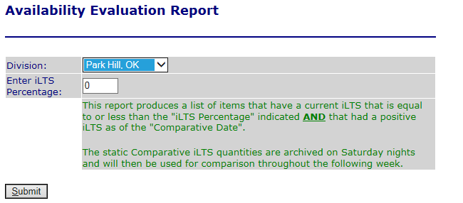

As stated in green in the above selection screen, the report is used to evaluate what items are no longer available or close to becoming not available so that users can review demand and supply to make more show as available if there is that possibility.